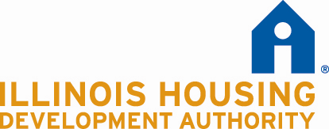

Long Term Operating Support
Special Demonstration Grant

Statewide Referral Network Agreement Certification

Development Name:
Development Location or Address:

The undersigned certifies that the Development referenced above will:

- Execute an Authority-approved Statewide Referral Network Agreement prior to closing on LTOS Funds;

- Maintain LTOS units for a minimum of the 15 year compliance period.

Owner/Sponsor:

By: ___________________________________________Date______________________
Signature

Name: Its:
Title

