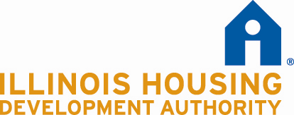

Long Term Operating Support
Special Demonstration Grant

Certification of IHDA’s Right to Inspect LTOS Units

Development Name:

Development Address:

Applicant:

The undersigned acknowledges that the Illinois Housing Development Authority (IHDA) has the right and will allow IHDA to inspect those units for which Long Term Operating Support Program funds have been requested, prior to any funding commitment.

Applicant:

By: ___________________________________________Date______________________
Signature

Name:

Its:
Title

